Component Interactions & Sequence Diagrams

This document provides the component-level interactions for the Pixelz Order Checkout system, illustrated with sequence diagrams for key business flows.

# 1. Submit Order - Success Flow

This diagram describes the sequence of interactions when a customer submits an order and the process is successful.

Steps:  
1. User sends request to submit an order.  
2. Controller validates and forwards to OrderService.  
3. OrderService calls PaymentService to process payment.  
4. On success, OrderService sends confirmation email via EmailService.  
5. OrderService sends request to ProductionService.  
6. Order status is updated in the database.  
7. Response is returned to the user.

## Sequence Diagram: Submit Order

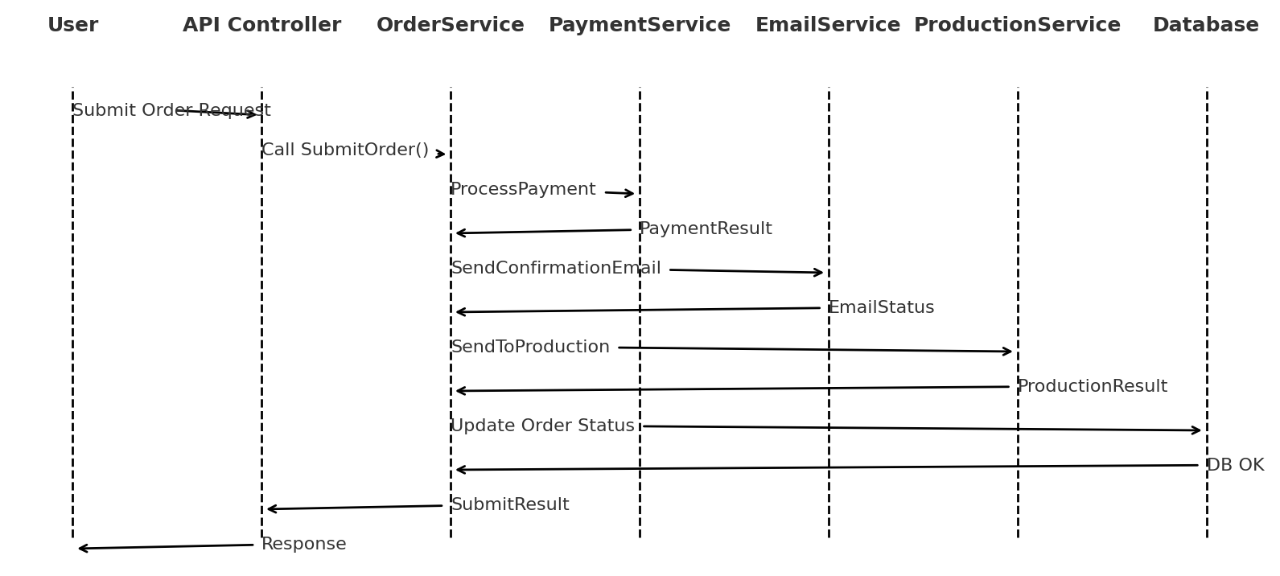

# 2. Search Orders

This sequence shows how a customer searches for their draft orders by name.

Steps:  
1. User sends GET request with customerId and optional order name.  
2. Controller calls OrderService to query the database.  
3. OrderService filters by customerId and optional name.  
4. Matching orders are returned as a list.

## Sequence Diagram: Search Orders

